Q1. Explain Function/ Method in java programming?

Ans:

* If a group of statements is repeatedly required then it is not recommended to write these statements every time separately. We have to define these statements as a single unit and we can call that unit any number of times based on our requirement without rewriting. This unit is nothing but function/method.
* The main advantage of functions is code Re-usability.
* Note: In other languages functions are known a methods,procedures,subroutines etc.
* Time saving
* Call many times

Methods States

1. Method Definition (working of methods)

public static void main(){

//definition of the method

}

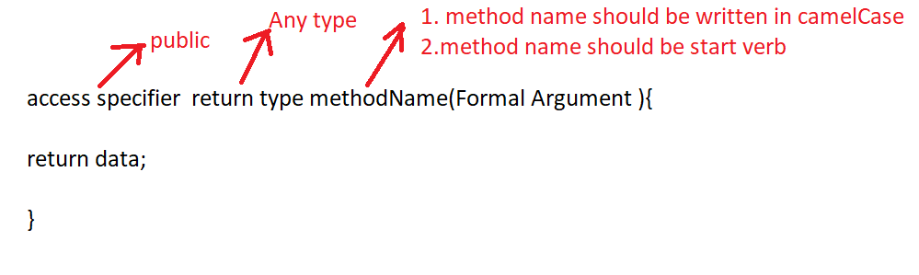

Methods Types on the Basis of Return Type and Argument

1. Taking nothing returning nothing

Example:

public void add(){

//definition of the method

1. Input
2. Operation
3. output

}

Calling the method

methodName();

1. Taking something returning nothing

Example:

public void add(int a,int b){

//1. no need to take input inside the method definition

//2. perform operation

//3. print result

}

//Taking nothing returning nothing

import java.util.Scanner;

class A1{

public static void add(){

Scanner kb=new Scanner(System.in);

System.out.println("Enter Number 1 : ");

int n1=kb.nextInt();

System.out.println("Enter Number 2 : ");

int n2=kb.nextInt();

int n3=n1+n2;

System.out.println("Addition : "+n3);

}

public static void main(String args[]){

add();//calling of the Addition function

add();

}

}

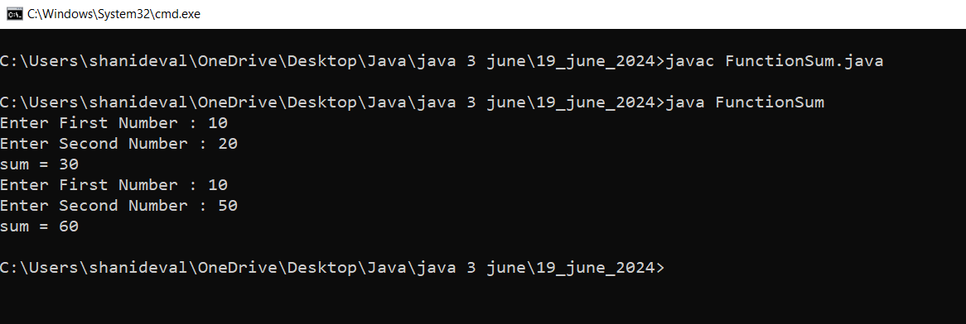

Q2. Write a java program to check given number is even or odd using method(Taking nothing returning nothing)

//Taking nothing returning nothing

import java.util.Scanner;

class A1{

public static void evenodd(){

Scanner kb=new Scanner(System.in);

System.out.println("Enter Any Number : ");

int n=kb.nextInt();

if(n%2==0){

System.out.println("This is Even Number");

}

else{

System.out.println("This is Odd Number");

}

}

public static void main(String args[]){

evenodd();//calling of the evenodd function

evenodd();

}

}

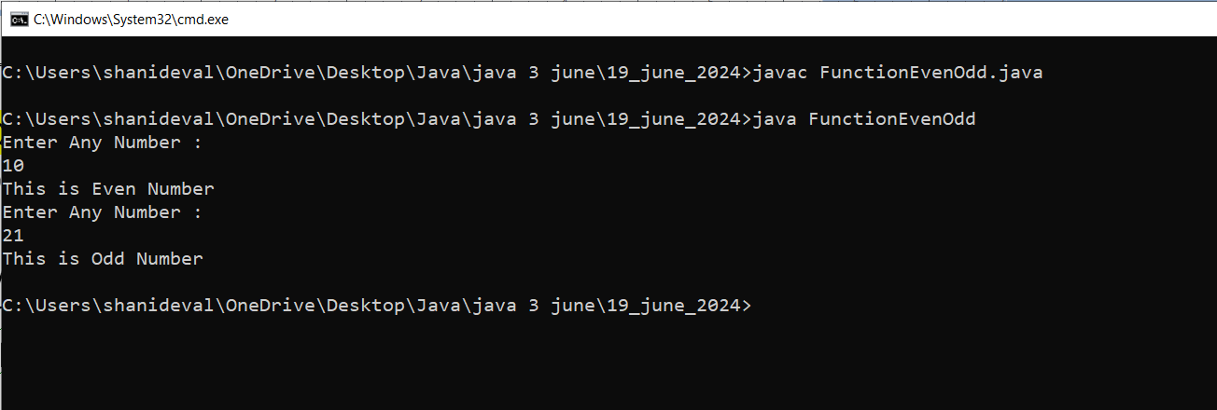

//Taking something returning nothing

import java.util.Scanner;

class A1{

public static void add(int n1,int n2){//formal Argument

int n3=n1+n2;

System.out.println("Addition : "+n3);

}

public static void main(String args[]){

Scanner kb=new Scanner(System.in);

System.out.println("Enter Number 1 : ");

int a=kb.nextInt();

System.out.println("Enter Number 2 : ");

int b=kb.nextInt();

add(100,200);//calling of the Addition function

// Actual Argument

add(a,b);

}

}

